BBT S9- Over/Under Performance By League
03-01-2017
- When we click on 'S9', we will get the report showing the punters performance in a particular league for Over/Under bet types. Top 8 punters report will be shown for non-live and live bets win/lose.

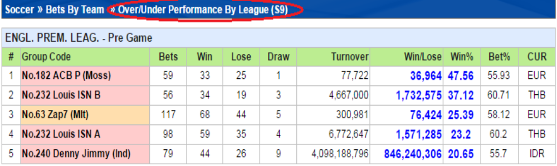

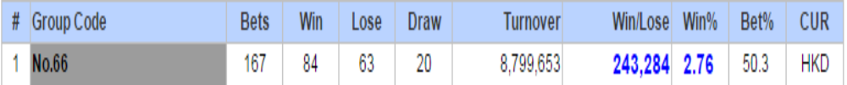
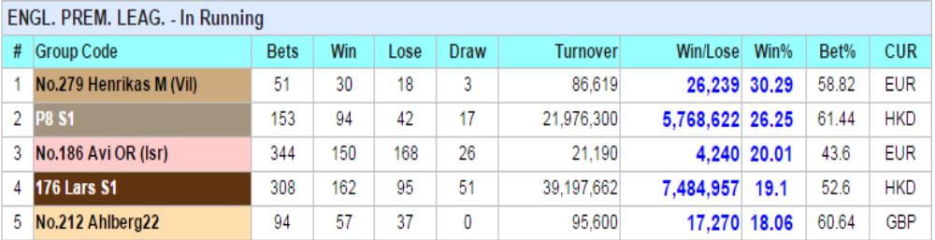
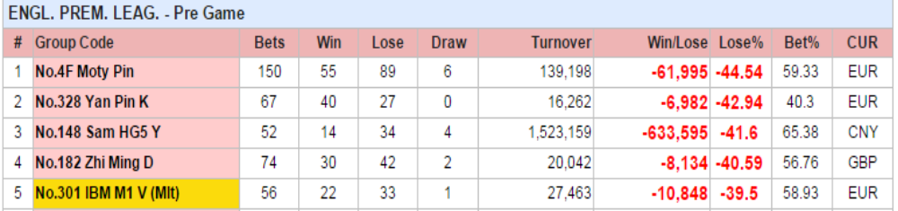
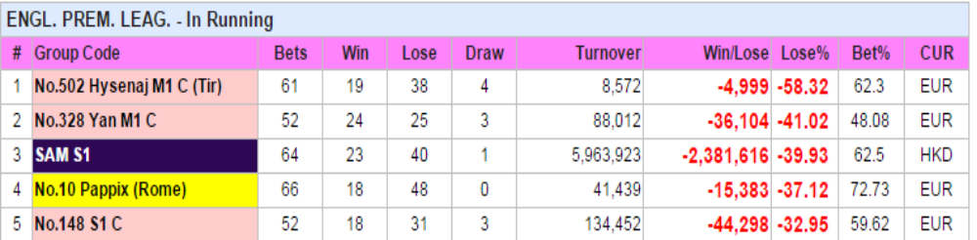

# | Header | Info
1 | Serial Number
2 | Group Code | This is a particular group code (Punter Code) through which bets have been placed for the selected league
3 | Bets | Total number of bets placed by members of the group
4 | Win | Total number of bets won in the group
5 | Lose | Total number of bets lost in the group
6 | Draw | Total number of bets drawn in the group
7 | Turnover | Total money or stake placed by that group
8 | Win/Lose | Total money won or lost by that group
9 | Win% | Win percent. Calculation is given below
10 | Bet% | Bet % Percent. Calculation is given below
11 | CUR | Currency in which bet is placed.

Calculation of Win/Lose Percent Live/Non-Live:

Case When Sum (en_0651c04_leagueperformance_soc.nonl_totalwinlose) = 0 Then
0.001 Else Sum (en_0651c04_leagueperformance_soc.nonl_totalwinlose) End /
(Sum (en_0651c04_leagueperformance_soc.nonl_totalturnover) + 0.0001) * 100 As winpercent
Explanation:
If Non-Live total winlose = 0 then 0.001
else
(Non-Live total winlose/Non-Live total turnover +0.001)*100 will give win percent

Calculation of Bet Percent Live/Non-Live:
Case When Sum (en_0651c04_leagueperformance_soc.nonl_totalbetcount)= 0 Then
0.001 Else Sum (en_0651c04_leagueperformance_soc.nonl_winbetcount) End /
(Sum (en_0651c04_leagueperformance_soc.nonl_totalbetcount) + 0.0001) * 100 As betpercent
Explanation:
If Non-Live total betcount = 0 then 0.001
else
(Non-Live total win betcount/Non-Live total betcount +0.001)*100 will give bet percent

Condition for groups present in the S8 report:

- Only top 8 smart groups will be shown for Win and Lose.
- Groups which are not present in en_0651c91_ignoresmartids_bbts8. This means groups which are ignored using Trading Params > Ignore Punters - S8 And S9 will not appear here.
- Groups will appear which are having
Sum (en_0651c04_leagueperformance_soc.nonl_totalbetcount) >= 50
50 is the minBetsCount which is set in scrips > params for both Live and not live win/Lose.
    - For Live/Non-Live Win Bets
Case: When Sum(en_0651c04_leagueperformance_soc.nonl_totalwinlose)= 0 Then 0.001
Else
Sum (en_0651c04_leagueperformance_soc.nonl_totalwinlose)/
Sum (en_0651c04_leagueperformance_soc.nonl_totalturnover) + 0.001)*100 >= 0
Therefore, if nonl_totalwinlose is not 0, then it will fetch all records where win% >= 0

    - For Live/Non-Live Lose Bets
Case: When Sum (en_0651c04_leagueperformance_soc.nonl_totalwinlose)= 0 Then 0.001
Else
Sum (en_0651c04_leagueperformance_soc.nonl_totalwinlose) End /
(Sum (en_0651c04_leagueperformance_soc.nonl_totalturnover) + 0.001) * 100 < 0
Therefore, if nonl_totalwinlose is not 0, then it will fetch all records where win% < 0

